Multi-tiered System of Support (MTSS)
K-12 Handbook

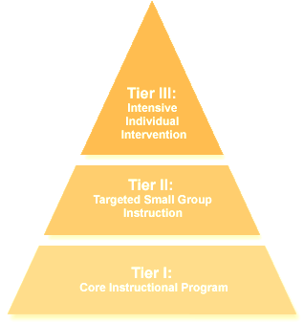

2020-2021
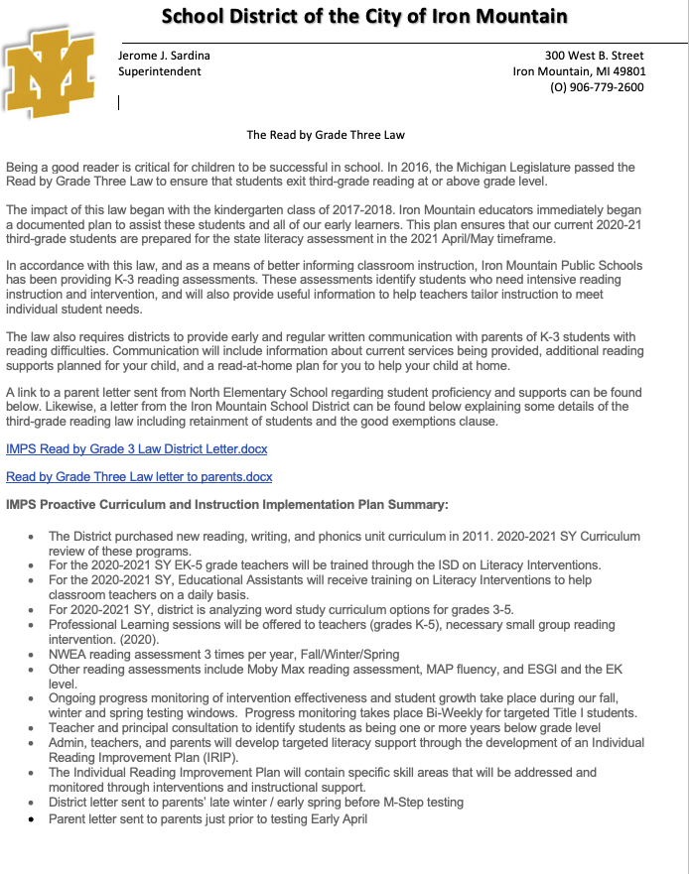
Table of Contents
General Information: When All Means All | Multi-tiered System of Support (MTSS): Foundational beliefs  RTI Tiered Instruction  MTSS Teams  MTSS Team Responsibilities
Professional Learning Communities and MTSS | Purpose of the Professional Learning Community (PLC)  MTSS Instructional Cycle—The Work of a PLC  Student Learning Outcomes (SLOs)
Assessments | Common Assessments  Schoolwide Benchmarking
Tier 1 Process | Tier 1  MTSS Tier 1 Core Instruction  Goal Setting NWEA
Tier 2 Process | Tier 2
Tier 3 Process | Tier 3  MTSS Student Assistance Team (SAT) Process  Tier 3 Progress Monitoring Guidelines Graduate Criteria  Tier 3 Special Education Child Find and Evaluation Procedures
Programming Guidelines | Guidelines Regarding Federal Programming Requirements  Academic Behavior Checklist
Intervention Menus | Reading Interventions  Math Interventions
Appendix | Student Assistance Team (SAT) Forms  Student Assistance Team (SAT) Screening Summary Form  Student Assistance Team (SAT) Intervention Plan For Student Assistance Team (SAT) Plan Evaluation Form  Student Learning Outcomes (SLOs)  Elementary ELA SLO Process 2020-2022  Elementary Math SLO Process 2020-2022  Secondary SLO Process 2020-2022  Student Learning Objective Chart  MasteryConnect (MC) Districtwide implementation 4-Year Plan  SLO Reflection Cycle  Benchmarking Calendar and Assessment Matrix  Elementary Cut Score Progressions by Grade Level  Secondary Cut Score for Risk Calculation

General Information: When All Means All

Multi-tiered System of Support (MTSS):
Foundational Beliefs

Multi-tiered Systems of Support (MTSS), formerly Response to Intervention (RtI), is a framework of instruction that provides support to ALL students to ensure mastery of grade-level content standards. The tiers of MTSS provide varying levels of support for students who are struggling to reach mastery as well as those to exceed grade-level.

MTSS provides a framework that incorporates screening, progress monitoring and data-based decision making to provide effective instruction.

The Michigan Department of Education obtains the philosophy for MTSS as a comprehensive framework comprising a collection of research-based strategies designed to meet the individual needs and assets of the whole child.

There are seven critical components that guide the MTSS framework in the Iron Mountain Public School District. These components are:
- A collective responsibility for ensuring growth and success for all learning is assumed by each person within the system (educators, learners, and community)
- A proactive approach to ensuring that each and every learning experiences a quality education design to expand learners’ potential
- A commitment to use a systematic problem-solving process to improve outcomes for all learners
- A commitment to ongoing, effective support for educators and leaders including professional learning, feedback, and coaching
- A commitment to use data as a basis for information gathering and to avoid making assumptions
- Attention to fidelity of implementation, honoring both qualitative and quantitative measures
- An investment in systems to promote durability and the scaling of MTSS

MDE MTSS Team, (2018). Michigan Department of Education Multi-Tiered System of Support Practice Profile, MDE, Lansing Michigan

General Information: When All Means All

RtI Tiered Instruction

Tier 1 instruction, also known as core instruction, is at course/grade level instruction that each student receives on a daily basis. For the majority of students, Tier 1 instruction will meet their academic needs. For approximately 80% of students Tier 1 instruction will meet their academic and/or behavioral needs.

Tier 2 instruction is supplemental instruction, as course/grade level, for students who need additional support in learning course/grade level material. Tier 2 instruction is intended to be timely and coordinated with Tier 1 instruction. Approximately 20% of students should need tier 2 instruction in the ideal MTSS framework. Tier 2 needs and interventions are identified during PLC conversations referencing the four critical questions.

Tier 3 instruction is intensive support provided to students who are struggling with significant learning gaps and need academic and/or behavioral support. Typically, these students do not have the appropriate course/grade level skills yet to be successful in solely Tier 1 and Tier 2 instruction. Tier 3 provides yet an additional level of intervention to help students develop foundational skills. Students receiving Tier 3 instruction also receive Tier 1 and 2 instruction. Students are entered into the Tier 3 interventions based on the referral to the Student Assistance Team (SAT).

The diagram below illustrates the three tiers.

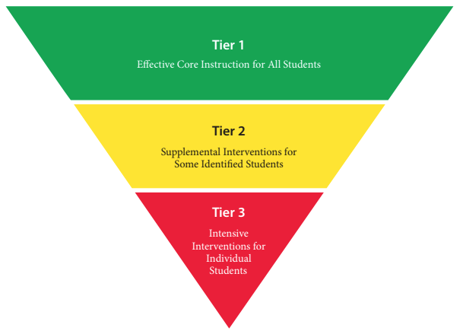

Buffum, Mattos, Weber. Simplifying Response to Intervention Four Essential Principles, Solution Tree Press, 2012

General Information: When All Means All

MTSS Teams

 | Team Purpose | Team Members | Frequency of Meetings
Teacher Teams/PLC | The team has five main functions:  - Clearly define ELBs  - Provide Tier 1 instruction  - Assess student learning and effectiveness of instruction  - Analyze data to identify students in need of additional support  - Take lead responsibility for Tier 2 interventions | - Course/grade level teams  - Department teams  - Interdisciplinary | Monthly
Student Assistance Team | Primary function is to analyze various forms of data to determine how to best meet the needs of students requiring Tier 3 interventions.  - Determine students’ academic/behavioral needs  - Diagnose causes of struggles in Tier 1 and 2  - Determine appropriate intervention  - Monitor student progress  - Revise intervention as needed  - Determine appropriate next steps for students | - Principal  - Social worker/counselor/school psychologist  - Intervention Lead  - Title 1 Interventionist (if applicable)  - General education teacher(s)  - Special education teacher/representative  - School nurse  - EL teacher, as needed  - Parent (invited, but not required) | Monthly/As Needed

General Information: When All Means All

MTSS Team Responsibilities

The diagram below illustrates the roles of the MTSS teams at the building level

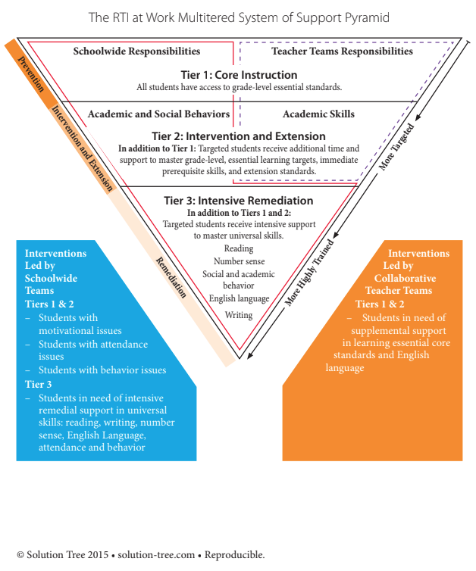

Professional Learning Communities and MTSS

Purpose of the Professional Learning Community (PLC)

“The most promising strategy for sustained, substantive school improvement is developing the ability of school personnel to function as professional learning communities” (DuFour & Eaker, 1990).

PLCs provide educators an avenue to collaborate regarding student learning and effective instructional strategies. The three concepts of the PLC include clarifying what each student will learn and how educators will ensure the learning, building a collaborative culture because the work cannot be completed in isolation, and using various forms of data to monitor student learning and respond to the learning in effective methods.

Collaboration is the key of the PLC, “the power of teachers is enhanced when teachers work collaboratively in highly effective teams” (Eaker, 2016).

The PLC discussions are guided by the four critical questions:

- What is it we expect our student to learn?
  - Clarifying and adding meaning to standards
  - What the benchmark, if met, would look like in student work
  - Common scoring, learning targets, pacing
- How will we know when they have learned it?
  - Collaborative development and the use of common formative assessments
  - Quick checks for understanding
- How will we respond when some students do not learn?
  - Differentiated instruction, MTSS
- How will we respond when some students already know it?
  - Differentiated instruction

Eaker, Robert. Kid by Kid, Skill by Skill: Becoming a Professional Learning Community, presented at Professional Learning Communities as Work Institute, Minneapolis, MN, June, 2016.
Professional Learning Communities and MTSS

MTSS Instructional Cycle – The work of a PLC

The following diagram illustrates the MTSS Instructional Cycle—The work of the PLC. The diagram shows how SLOs, Tiered instruction and PLC come together to provide an effective MTSS system.

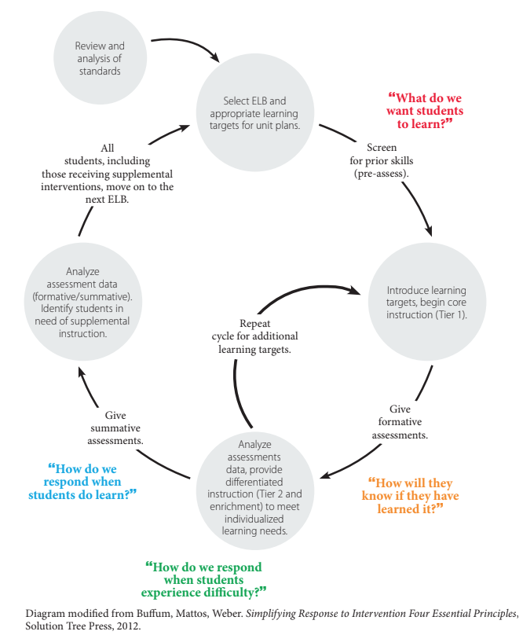

Professional Learning Communities and MTSS

Student Learning Objective (SLOs)

In order to answer the first PLC critical question, “What do we want our students to learn?”, educators need to determine what the essential benchmarks are for each unit of instruction. In order to prioritize the content standards there are four categories for reflection.

- What is essential to know and do?
- What is important to know and do?
- What is worth being familiar with?
- What is nice to know?

SLOs are imperative for student learning and are often the foundational pieces for further learning. There are three criteria to be used when identifying these:
- Endurance: Does knowledge of this objective go beyond performance on a single test/assessment? Typically, these focus on lifelong skills, concepts, and processes.
- Leverage: Does the knowledge of this objective carry over to other content areas? Is it widely applicable?
- Readiness for further study: Does the objective provide foundational knowledge for learning at another grade level or level of instruction?

SLOs that meet the three criteria above are identified as essential. If it meets two of the criteria it is an important standard. If it only meets one of the criteria it is a nice-to-know standard.

It is the expectation of the teacher that all standards and benchmarks are taught. The student learning objectives are those areas of knowledge that students are expected to master within the class/grade. Students who struggle to master the SLOs are provided further instruction through Tier 2 and possibly their 3.

IMPS has currently identified SLOs for Math and English/Language Arts.
- K-12 English/Language Arts SLOs
- K-12 Math SLOs

Gregory, G., Kaufeldt, M. and Mattos, M. Best Practices at Tier 1. Solution Tree Press, Bloomington, IN, 2016

Assessments

Common Assessments

We give common assessment so we can identify specifically which students did not demonstrate mastery of essential standards. Because we give common assessments to measure student mastery of essential standards, assessments should identify students that need additional help and support. Additionally, if an assessment measures more than one essential standard, the rest results must provide more than an overall score for each student. They also should specifically delineate which standards each student did not pass

Essential question: Specifically, which students did not demonstrate mastery?

Identify effective instructional practices: Because our teachers have autonomy in how they teach essential standards, it is vital that common assessment data help validate which practice where effective. This can be done best when common assessment results are displayed in such a way that allows each teacher to compare their students’ results to other teachers who teach the same course.

Essential question: Which instructional practices proved to be most effective?

Identify patterns in student mistakes: Besides using common assessment results to identify best instructional practices, this data should also be used to determine ineffective instructional practices. Patterns emerge that can point to weakness or gaps in initial instruction when analyzing the types of mistakes that failing students make.

Essential question: What patterns can we identify from student mistakes?

Measure assessment accuracy: Through item analysis of the assessment, a team can determine the validity of each question. Over time, this will build a team’s capacity to create better assessments.

Essential question: How can we Improve this assessment?

Plan and target interventions: The ultimate goal of any PLC is to ensure high levels of learning for all students. If a team uses common assessments to identify students in need of additional help, determine effective and ineffective instructional practices, and measure the validity of the assessment, then they should have the information needed to plan and implement targeted interventions to assist the students that need help.

Essential question: What interventions are needed to provide struggling students additional time and support?

Modified from © Mattos 2016. SolutionTree.com Reproducible

Assessments

Schoolwide Benchmarking

Benchmarking data is one piece of data to be considered regarding students’ progress during PLC meetings. It is a piece of data for teachers to consider in PLC discussions regarding meeting individual student needs – both the needs of students who do not have the necessary skills and those who are already proficient. See Benchmarking Calendar and Assessment Matrix for more details

Benchmark assessments serve three purposes:
- Allow students to be screened to monitor their academic progress. Students below benchmarks are identified for further assessment.
- Help set a baseline for school goal setting purposes.
- Provide data on school programming effectiveness.

Early-Kindergarten – Grade 4:

- All students are benchmarked (reading and math) three times per year using NWEA.
- All students are benchmarked in reading three times per year using MAP Reading Fluency
- All students in grades 1-4 are benchmarked (reading and math) three times per year using STAR Math and STAR Reading.
- Early-Kindergarten and Kindergarten students are benchmarked (reading and math) three times per year using ESGI.

Grades 5-11:

- All students will be benchmarked (reading and math) three times per year using NWEA.

Homeschool Partnership:

- All students will be benchmarked (reading and math) three times per year using NWEA.

Tier 1 Process

Tier 1
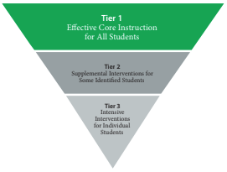
Entry Criteria:

Tier 1, Core instruction, is provided to all students.

Instruction:

Tier 1 instruction included, but is not limited to:
- Research-based instructional strategies
- Data-driven decision making and instruction
- District approved core curriculum
- Differentiated instruction
- Flexible grouping

Benchmarking and Assessments:

All students will be benchmarked multiple times throughout the school year in the areas of reading and math. See Benchmarking Calendar and Assessment Matrix for specific assessments windows. Benchmarking data is one piece of data to be considered regarding students’ progress during PLC meetings. It is a piece of data for teachers to consider in PLC discussions regarding meeting individual student needs – both the needs of students who do not have the necessary skills and those who are already proficient.

Students will have multiple opportunities to demonstrate their skills through common formative and summative assessments. This data should be used in PLC discussions regarding the four critical questions (ref. p.9).

Professional Learning Communities (PLC):

Professional Learning Communities will meet monthly to review student learning. The purpose of these meetings is to discuss the four critical questions in regards to current student learning. Teachers will identify the various students’ needs and discuss how, as a team, they will work to meet the needs of all students.

Tier 1 Process

MTSS Tier 1 Core Instruction and Tier 2

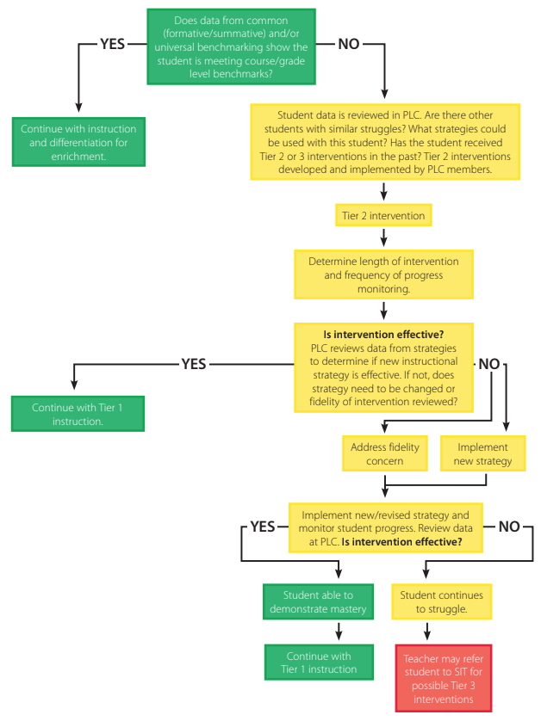

Tier 1 Process

Goal Setting (NWEA)

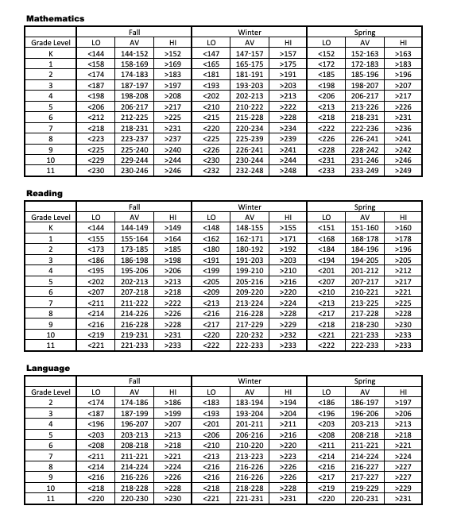

**Mapping the Road to College (NWEA online resource)

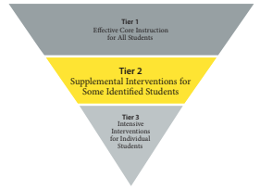
Tier 2 Process

Tier 2

Entry Criteria:

Tier 2 interventions are intended for students who are struggling to meet course/grade level expectations. These interventions take place in addition to Tier 1, core instruction.

Instruction:

Tier 2 instruction included, but is not limited to:
- Flexible grouping
- Research-based instructional strategies
- Data-driven decision making instruction
- Differentiated instruction

Progress Monitoring:

Teachers will monitor student learning in their Tier 2 groups using appropriate tools for the specific interventions that will provide data for the PLC to monitor students’ progress

Professional Learning Communities (PLC):

Tier 2 interventions will be determined during PLC meetings. Classroom teachers will review the common assessments and other forms of data to identify students who need Tier 2 interventions. Classroom teachers are responsible to take the lead in determining Tier 2 intervention needs while utilizing the expertise of intervention teachers.

Decision-Making Process:

PLC conversations should continually include discussion regarding student success. If students continue to struggle to learn a specific skill or demonstrate more significant need, there should be discussion at the PLC regarding the appropriateness of the intervention used or the fidelity of the intervention. After multiple interventions have been unsuccessful, the PLC should discuss if a School Assistance Team Referral is appropriate for a specific student.

Tier 3 Process

Tier 3

Entry Criteria:

Tier 3 Interventions are intended for students who have below course/grade level learning gaps. These Interventions take place in addition to Tier 1, core instruction and Tier 2 interventions. It is not required that the students score below the 10th percentile in any standardized assessment to qualify for Tier 3 interventions. A student qualifies for Tier 3 interventions based on recommendation of the School Assistance Team (SAT) review of the student’s data. Each fall students who received Tier 3 interventions the spring prior, may begin receiving Tier 3 interventions without a SIT meeting, depending on the student’s current needs at the start of the school year.

Instruction:

Tier 3 instruction is specific to each student’s needs and is dependent on diagnostic assessment data.
Tier 3 is:
- Small group, or individual instruction
- Increased frequency of intervention
- Additional minutes to Tier 1 and Tier 2 instruction. Tier 3 occurring during the school day, in addition to scheduled Tier 2 intervention times, not in place of Tier 2 interventions (for example, seminar time, Title 1 services, resource room support)

Progress Monitoring:

Students receiving Tier 3 interventions will be progress monitored in a frequency based on the specific intervention being used. See Progress Monitoring Guidelines and Graduate Criteria for further details. Decisions regarding appropriate progress monitoring tools are made at the SIT meeting. The teacher providing the Tier 3 intervention is expected to frequently communicate student progress with the classroom/referring teacher.

Professional Learning Communities (PLC):

PLC conversations should continually include discussion regarding the student’s Tier 1 and Tier 2 progress. The classroom or referring teacher will participate in the SAT team’s discussions of the student receiving Tier 3 interventions. See MTSS Student Assistance Team (SAT) Process on page 18 for more details.

Decision-Making Process

See MTSS Student Assistance Team (SAT) Process on page 18 for more details.

Tier 3 Process

MTSS School Assistance Team (SAT) Process

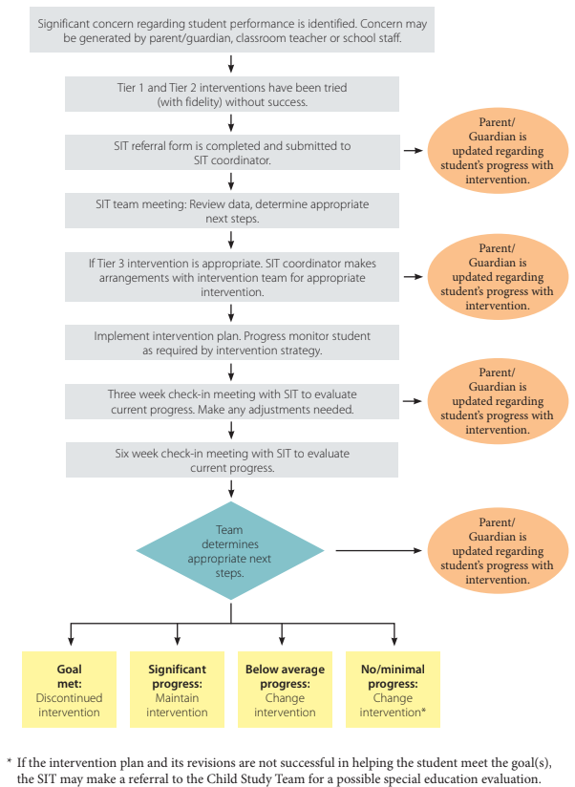

Tier 3 Process

Tier 1
Effective Core Instrucion for all students

Tier 2
Supplemental Interventions for Some Identified Students

Tier 3
Intensive Interventions for Individual Students

Tier 3 Progress Monitoring Guidelines Graduate Criteria

Progress Monitoring:
- Typically occurs at a student’s instructional level (below course/grade level when necessary).
- When a student is progress monitored (PM) at a performance level that is below course/grade level, three consecutive data points must occur above the aimline. Teachers will continue to set a new goal at the subsequent course/grade level until the student has met graduate criteria at their current course/grade level.
- Progress Monitoring
  - Occurs at performance level
  - Bi-monthly for both math and reading
    - Progress monitoring can occur at different frequencies based on SAT meeting discussion
- Use a tool that matches your diagnostic outcome
- After graduating a student, PM for two additional months bi-weekly (every other week)

Graduate Criteria
- Three consecutive data points are expected above the aimline (their current course/grade level)
- Decision is based on data point; not length of intervention
- The SAT decision is a critical component of the process; the data from AIMSweb, STAR 360, or other sources is one piece of data to be reviewed. Teacher input, staff input, communication, etc. are essential.

Exit Criteria:
- The student left district
- The parent requested for Tier 3 services to be discontinued

Tier 3 Special Education Child Find and Evaluation Procedures

What forms are necessary to implement this procedure?
- Prior Written Notice
- Review of Existing Evaluation Data (REED)
- Request for Consent
- Evaluation Report
- Individualized Education Program (IEP)
- Procedural Safeguards
Responsibility for Public Awareness
As part of a child find responsibility, districts must inform the public about available special education programs and services and how to access those programs and services. Information regarding Special Education Opportunities and Procedures, Activities and Outreach Methods for Awareness of Services, Types of Diagnostic Services, and Basic Programs and Services are available on the Dickinson-Iron ISD website www.diisd.org.
Procedure for Responding to a Request for an Evaluation (Grades Pre-K through 12)
All requests for an evaluation must be in writing. If a parent request is made verbally, the person to whom the request is made informs the parent that the request needs to be in writing.

A request for a special education evaluation can come from a parent or guardian, or other appropriate educational service agency staff whose training and relationship to the student provides knowledge to reasonably suspect that the student has a disability.

When a written request is received by any person in the district, that person must submit the request to the building administrator who will then date stamp the request with the date of receipt and the request will be sent immediately to the special education teacher for processing. The special education teacher will provide a copy of the procedural safeguards to the parent or guardian.

A team, consisting of the building administrator, the general education teacher, the special education teacher, the ISD School Psychologist, and the parent must decide whether or not to initiate the evaluation to determine if the student is a student with a disability and is in need of special education and related services. When making this decision, Response to Intervention (RTI) does not diminish a district’s obligation under the IDEA to obtain parental consent and evaluate a student in a timely manner. When there is reason to suspect that a student might have a disability and needs special education and related services as a result, the IDEA’s initial evaluation provisions begin, regardless of whether the district plans to or is currently utilizing RTI strategies with the student. (Memorandum to State Directors of Special Education [OSEP 2011])
Procedure for REED
The special education teacher coordinates the members of the IEP team and other appropriate members to review:
- Evaluations and information provided by the parents of the child,
- Current classroom-based, local, or state assessments, and classroom-based observations,
- Observations by teachers and related service providers, and
- Areas of suspected disability.

On the basis of that review and input from the child’s parents, the team will identify what, if any, additional data are needed to determine whether the student is a student with a disability and if the student needs special education and related services.

The special education teacher documents the review of the existing evaluation data as well as the need for any additional information on the REED form.

If additional information is needed the special education teacher will develop an evaluation plan.
Procedure for Providing Notice and Obtaining Consent for Initial Evaluation
When a request for an initial evaluation is received, the special education teacher must provide notice within 10 school days. The notice must include:
- A description of the action proposed or refused by the district.
- An explanation of why the district proposes or refuses to take the action.
- A description of each evaluation procedure, assessment, record, or report the district used as a basis for the proposed or refused action.
- A statement that the parents of a child with a disability have protection under the procedural safeguards of this part.
- Sources for parents to contact to obtain assistance in understanding the provisions of the Individuals with Disabilities Education Act (e.g., Michigan Alliance for Families Services, intermediate school district representative, and local supervisor or director).
- A description of other options that the IEP team considered and the reasons why those options were rejected.
- A description of other factors that are relevant to the district’s proposal or refusal.
- In addition to the notice, the special education teacher sends the REED document and Notice for Consent form to the parent requesting consent to evaluate (if an evaluation is needed).

If written consent is not provided after the first attempt, the special education teacher will make and document multiple attempts on the REED form in Illuminate. Attempts to obtain consent should be made using different methods. “Multiple” attempts means at least three times.

If the parent provides no response to multiple attempts to obtain written consent for evaluation or denies consent, the special education teacher will provide notice that the district will not conduct an evaluation due to lack of parental consent.
Conduct an Evaluation and Schedule an IEP Meeting
If parental consent to evaluate is obtained, the special education teacher coordinates the evaluation and schedules the appropriate evaluators to begin the evaluation. See chart 1 for required evaluators. If the special education teacher determines the district is unable to provide the required evaluators in the timeline, the special education teacher will contact ISD for support in securing evaluators. Evaluators will schedule and conduct evaluations.

The special education teacher will ensure that within 30 school days from the receipt of consent, the evaluators will conduct the evaluations and develop the multidisciplinary evaluation team report. The special education teacher will schedule an IEP team meeting to be held within the 30 school-day timeline. The timeline may be extended if agreed upon by the district and the parent. If necessary, the special education teacher will complete an extension in the REED form in Illuminate to document the extension which shall be in writing and measured in school days.
Procedure for Convening the IEP Team
Within the 30 school day timeline, the special education teacher contacts parent to determine mutually agreed-upon time and place for the IEP team meeting. The special education teacher will document the attempts to contact the parent in the IEP form in Illuminate.

The special education teacher will send an IEP invitation to all required IEP team members. Required members include parent, not less than one general education teacher, not less than one special education teacher or provider, district designee, and a person who can interpret the instructional implications of evaluation results. Additional members may include related service providers and, whenever appropriate, the student with a disability.
1. The special education teacher will secure a meeting room following district procedures.
2. Convene meeting on mutually agreed-upon date and time
3. Develop IEP

Within 7 school days from the date of the IEP meeting, the special education teacher will provide notice of an offer of a free appropriate public education (FAPE) or determination of ineligibility. The special education teacher will document the mode and date of delivery on the IEP form in Illuminate.
Procedure for Providing Notice of a Free Appropriate Public Education
The notice of a free appropriate public education must include:
- A description of the action proposed or refused by the agency.
- An explanation of why the agency proposes or refuses to take the action.
- A statement that the parents of a child with a disability have protection under the procedural safeguards of the Individuals with Disabilities Education Act and, if this notice is not an initial referral for evaluation, the means by which a copy of a description of the procedural safeguards can be obtained.
- Sources for parents to contact to obtain assistance in understanding the provisions of this part (e.g., Michigan Alliance for Families, ISD representative, and local supervisor or director).
- A description of other options that the IEP team considered and the reasons why those options were rejected.
- A description of other factors that are relevant to the agency’s proposal or refusal.
- Where the programs and services are to be provided.
- When the IEP will begin.
Procedure for Requesting & Obtaining Consent for the Initial Provision of Programs & Services
In addition to the notice including the provision of FAPE, the special education teacher sends a copy of the IEP and Notice for Initial Provision of Program and Services to the parent requesting consent for the provision of services.
Procedure for When Consent is Not Obtained
If after 10 school days from the parent’s receipt of the notice and initial offer of FAPE, the parent provides no response to multiple attempts to obtain written consent for provision of services or denies consent, the special education teacher will provide notice that the district will not implement the IEP.

Note: If the parent of a child fails to respond to a request for consent, or refuses to consent to the initial provision of special education and related services, the district will not be considered to be in violation of the requirement to make FAPE available.
Procedure for Implementing the IEP
Once consent for the provision of services is received by the district, the special education teacher date stamps the consent and places it in the student’s official special education file.

The special education teacher ensures the IEP is implemented as soon as possible, and not more than 15 school days after receipt of parent’s consent to the initial provision of services. The parties may agree to a later initiation date if the later date is clearly identified in the IEP.

The special education teacher distributes copies of IEP to all district employees who will be working with the student.
Chart 1—Required Evaluators
Eligibility Category Being Considered | Required Evaluators
Cognitive Impairment  R 340.1705 | Psychologist
Emotional Impairment  R 340.1706 | Psychologist or psychiatrist and school social worker
Hearing Impairment  R 340.1707 | Audiologist and an otolaryngologist or otologist
Visual Impairment  R 340.1708 | Ophthalmologist or optometrist
Physical Impairment  R 340.1709 | Orthopedic surgeon, internist, neurologist, pediatrician, family physician, or any approved physician
Other Health Impairment  R 340.1709a | Orthopedic surgeon, internist, neurologist, pediatrician, family physician, or any approved physician
Speech and Language Impairment  R 340.1710 | Teacher of students with a speech and language impairment or a speech and language pathologist
Early Childhood Developmental Delay  R 340.1711 | Evaluators are determined by a team
Specific Learning Disability R 340.1713 | Student’s general education teacher (or a teacher qualified to teach student’s age) plus a person qualified to conduct individual diagnostic exams, such as a school psychologist, authorized provider of speech and language, or a teacher consultant
Severe Multiple Impairments  R 340.1714 | Psychologist and, depending upon the disabilities in the physical domain, evaluations required in: R 340.1707, R 340.1708, R 340.1709, R 340.1709a, or R 340.1716
Autism Spectrum Disorder R 340.1715 | Psychologist or psychiatrist, authorized provider of speech and language, and a school social worker
Traumatic Brain Injury  R 340.1716 | Assessment from family physician or any approved physician
Deaf-blindness  R 340.1717 | Ophthalmologist, optometrist, audiologist, otolaryngologist, otologist, family physician or other approved physician; teacher of students with visual impairment; and a teacher of students with hearing impairment

Programming Guidelines

Guidelines Regarding Federal Programming Requirements

Those providing intervention services and funded via Title 1 and ADSIS:

The district business office will send certifications to building administrators two times a year to verify the funding source and percentage of work under these funding sources (Title I and ADSIS). This will negate the need for Time Record completion by Title teacher as was past practice.

Compacts and Guardian Permission Forms

Each site (including principal, intervention teachers, classroom teachers, parents) is responsible to develop a compact/guardian permission that identifies the partnership between home and school. This compact/guardian permission will be written in such a manner that will meet requirements for both ADSIS and Title I in order to avoid redundancy and confusion in distribution.

Parent/Guardian Permission:
- Must be presented to parent/guardian up to three times as an attempt to obtain a signature.
- Forms must provide a checkbox giving permission and another checkbox refusing permission.
- Permission form will state that programming will proceed if not received by a predetermined date; before that time frame has ended, two additional parent/guardian attempts must be made and documented.
- Verbal permission is acceptable and must be documented on a permission form.
- Each site is to keep record of the permission forms
- The date of effectiveness should reference one year to allow for services to begin the first day of the next school year.
- Each site’s developed Title compact/guardian permission must be placed in the site’s Title Google drive file. Sites are required to send an email to OCI notifying of updated Title Compact/guardian permission.
- A site with ADSIS federal funding only will send a copy of the site developed guardian permission via email to OCI upon completion yearly.
- Building administrator will share the revised compact/guardian permission with site Title and ADSIS teachers for use each year.

Guardian permission forms are to be saved for a total of three years. Each side will develop a system to save these documents should they be requested by MDE. If utilizing the Cumulative Folders, sites will need to determine another means to save these in a centralized location for a period of three years.

While MDE would not request to see permissions for Compensatory Education funded intervention, each site will save these permission forms for a total of three years.

Service Hour Spreadsheets (ADSIS):

ADSIS funded interventionists will complete the service hour spreadsheets on or before the 5th of each month. OCI will send the updated version at the start of the school year.

Special Education Service Clarification:
- ADSIS cannot serve ANY special education student (speech included); this does not mean that they cannot receive Tier 2 and Tier3 support.
- ADSIS funded teachers are not the only staff members allowed to provide intervention support. Title I classroom teachers, compensatory funded teachers, or other trained staff can provide interventions.
- Title I can serve special education students, but not in the area of their IEPs.
  - IEP goal for reading only: could receive math intervention by a title teacher
  - IEP goal for math only: could receive reading intervention by a title teacher
  - IEP goal for behavior only: could receive either math/reading intervention by a title teacher

Monitoring Interventions & Academic Behavior: Tier 3:

The SAT process will be completed for any student who receives ADSIS services. Review Tier 3 and MTSS Student Assistance (SAT) process.

Intervention Menus

Interventions-Reading

Program | Grades | Description | Tiers
MobyMax | K-8 | MobyMax is an online intervention tool that differentiates lessons for students based on placement tests and understanding of work. After the placement test, the results show the students' current grade levels and a breakdown of Common Core standards were met during the test and the standards students need to work on. | 1, 2, 3
Phonics for Reading | K-4 | Phonics for Reading is a research validated program that focuses on decoding, encoding (writing), fluency, and comprehension skills usually mastered in grades K to 3. The program uses explicit, teacher-directed instruction to introduce skills and strategies. | 2, 3
REWARDS  - Intermediate (4-6)  - Secondary (7-12) | 4-12 | REWARDS is a powerful research-based short term and specialized program for adolescent students in grades 4–12. The focus is on decoding multisyllabic words, identifying and understanding prefixes and suffixes, increasing word and passage reading fluency, building academic vocabulary, and deepening comprehension along with building confidence. | 2, 3
Houghton Mifflin Harcourt Reading/Literacy Toolkit  - Reading (1-3)  - Literacy (4-6) | 1-6 | The Literacy Toolkit is a comprehensive solution designed specifically for educators interested in incorporating elements of a Guided Reading program into their reading classroom. It helps all learners meet the Common Core State Standards, provides support for all proficiency levels in critical vocabulary that accelerates language acquisition and CCSS mastery. | 2
Khan Academy | 6-12 | Khan Academy is an online tool that offers practice and instructional resources across an increasing range of subjects and grades. It assesses a student’s ability and then differentiates lessons that meet the needs of the individual learner. | 1, 2
Read Naturally | 1-5 | Read Naturally combines research-proven reading intervention strategies to create an effective tool that individualizes instruction and improves reading proficiency. Students work with high-interest material at their skill level to improve fluency, vocabulary, and comprehension. | 2, 3
Orton-Gillingham | K-8 | Orton–Gillingham is an approach specifically designed to help struggling readers by explicitly teaching the connections between letters and sounds. This intervention is often used with students diagnosed with Dyslexia. | 2, 3
6-Minute Solution | K-12 | This program offers an easy-to-implement, quick, and inexpensive way to improve the fluency of all readers, including the areas of passage reading fluency, automatic word recognition, vocabulary, and comprehension. | 1, 2
Reading (continued)
Program | Grades | Description | Tiers
AlphaTales by Scholastic | K-1 | A series of 26 irresistible animal storybooks that build phonemic awareness & teach letter names and sounds. | 2
GrammarTales by Scholastic | 3-4 | A series of 10 read-aloud books that teach essential rules of usage and mechanics such as parts of speech, proper use of commas and quotation marks, and so much more. | 2
PALS Reading | K-6 | Peer-Assisted Learning Strategies, or PALS, is a scientifically-based peer-mediated instructional program developed by researchers at Vanderbilt University. The specific skills addressed at each grade correspond to the standards most frequently represented at each level of the curriculum. | 1, 2

Website Resources:

Intervention Menus

Interventions-Math

Math
Program | Grades | Description | Tiers
MobyMax | K-8 | MobyMax is an online intervention tool that differentiates lessons for students based on placement tests and understanding of work. After the placement test, the results show the students' current grade levels and a breakdown of Common Core standards were met during the test and the standards students need to work on. | 1, 2, 3
Bridges | K-8 | Bridges Intervention provides targeted instruction and assessment for essential K–5 mathematics skills within a tiered system of support. The small-group instruction and ongoing progress monitoring are consistent with a Response to Intervention (RTI) or Multi-Tiered System of Support (MTSS) framework. | 2, 3
RocketMath | 1-6 | Rocket Math is a supplemental learning program that teaches students addition,  subtraction, multiplication, division, and fractions. Specifically, the program teaches math facts–the basic building blocks of all math. | 1, 2, 3
Khan Academy | 6-12 | Khan Academy is an online tool that offers practice and instructional resources across an increasing range of subjects and grades. It assesses a student’s ability and then differentiates lessons that meet the needs of the individual learner. | 1, 2
PALS Math | K-6 | Peer-Assisted Learning Strategies, or PALS, is a scientifically-based peer-mediated instructional program developed by researchers at Vanderbilt University. The specific skills addressed at each grade correspond to the standards most frequently represented at each level of the curriculum. | 1, 2

Website Resources:
- News & Updates | Free - CommonCoreSheets
- Math Worksheets | Dynamically Created Math Worksheets
- PBISWorld.com Home Page
- Free Math Worksheets - Printable & Organized by Grade

Appendix

Student Assistance Team (SAT) Forms

Please fill out the Iron Mountain Public School Student Assistance Team Documentation and Tracking Form

Click Here

Appendix

Student Learning Outcomes(SLOs)

- K-12 English/Language Arts SLOs
- K-12 Math SLOs

